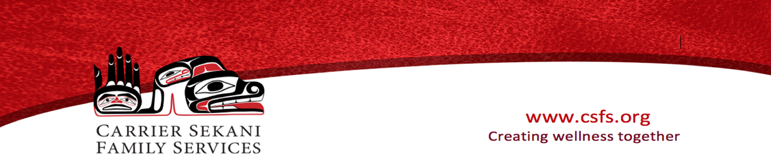

Dzee Ba’yugh Safe House Referral Form
Phone number: (778)-924-0004 Toll free # 1(877)-778-4835 Ext:101 E-mail: dzeeba’yugh@csfs.org
Section must be completed Date of referral:___________________________
Program referral ☐ or Residency referral ☐
Client full name:_________________________________ Date of Birth___________________ Age:_________
Address: __________________________________________ Email address: ___________________________
Phone Number: ________________________________________ Is it safe to call or text? Yes ☐ No ☐
Number of Children with client: _______________________ Do you identify as Indigenous? Yes ☐ No ☐
Medical condition (if any)_____________________________________________________________________
Interpreter Required? Yes ☐ No☐ If yes what language? ________________________________________
Emergency Contact: ____________________________ Contact number: ______________________________
Has abuse recently occurred? Yes☐ No☐ Ministry of child & family care (MCFD)- current☐ Past☐
Any form of no contact order in place? Yes☐ No☐ Family court orders? Yes☐ No☐
With whom:________________________________ D.O.B._______________________
Last Known Address:____________________________________________________
How did you hear about our service? _____________________________________________
Have you attended our services before? Yes☐ No☐
Please provide details of key relevant agencies that are involved (i.e. Housing, Legal Aid, Counselling, etc):
__________________________________________________________________________________________
Organization/ Referrer’s Details
Name:_____________________________________ Phone Number:__________________________________
Email:_____________________________________ Service:_________________________________________
Do you need to be notified of the outcome of the referral? Yes☐ No ☐
Clients consent to share information (Client Signature): _____________________________________________________

