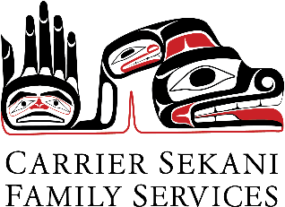
Community Mental Health &
Child and Youth Mental Health

Our Offices:
Burns Lake  Ph. (250) 692-2387  Referral emails:  Community Mental Health - communitymhreferral@csfs.org  Child and Youth Mental Health – cymhreferral@csfs.org | Fort St. James  Ph. (250) 996-7640 | Vanderhoof  Ph. (250) 567-2900 | Prince George  Ph. (250) 564-4079

Referral Form

Individual Seeking Support: |  | Date of Birth:
Preferred Pronouns or Preferred Name:
Home Address:
Primary First Nation/Band: | Home Community:
Home Phone:  Cell Phone:  Safe to leave a voicemail?: ☐ Yes ☐ No | Mailing Address:  (if different than home)
Parents/Legal Guardians (if client is a minor):
Other people in the home (e.g. partners, parents, siblings, children):
Please list any other adults involved (if applicable):
Other Children (if applicable):
Reason for this Referral:

Is there immediate risk of suicide? ☐ Yes ☐ No

Is this a request for Tele-health/Video conference services? |  | ☐ Yes | ☐ No
Is the client aware that this referral is being made? |  | ☐ Yes | ☐ No
Is family involved aware that this referral is being made? |  | ☐ Yes | ☐ No

Service referred to:
☐ Community Mental Health
☐ Child and Youth Mental Health

Referral comes from:
Name:

Agency:

Phone Number:

Signature:

Confirmation of Referral Received by Intake Worker (For Office Use Only):
Employee: | Date:

