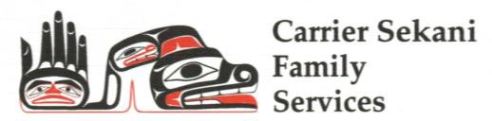Health & Wellness Program

Community-based Mental Health, Aboriginal Child & Youth Mental Health, Addictions Recovery, Indian Residential School Program, National Native Alcohol & Drug Abuse Program

|  |  |
| --- | --- |
| **Our Offices:** | **Questions? Call Mental Health (250) 567-2900** |

|  |  |  |  |
| --- | --- | --- | --- |
| Burns Lake  Ph. (250) 692-2387  **Confidential Fax Line: 1-888-690-9894** | Fort St. James  Ph. (250) 996-7640 | Vanderhoof  Ph. (250) 567-2900 | Prince George  Ph. (250) 564-4079 |

Referral Form: For Family & Individual Services

|  |  |  |  |
| --- | --- | --- | --- |
| Individual Seeking Support: | | Date of Birth: | |
| Family Home Address: | | | |
| Primary First Nation/Band: | Home Community: | | |
| Family Home Phone: | Mailing Address:  (if different than home) | | |
| Parents/Legal Guardians: | | | |
| Other people in the home (eg. partners, parents, siblings, children): | | | |
| Please list any other adults involved (if applicable): | | | |
| Other Children (if applicable): | | | |
| Reason for this Referral: | | | |
| Is this a request for Tele-health/Video conference services?  *if yes, contact practice team lead above* | | Yes | No |
| Is client/family involved aware that this referral is being made? | | Yes | No |

|  |  |
| --- | --- |
| **Referral comes from:** | |
| Name: | Title: |
| Agency: | Date: |
| Signature: | Phone Number: |

|  |  |
| --- | --- |
| **Confirmation of Referral Received (For HWP Use only) Complete and send a copy back to referral source** | |
| Employee: | Date: |
| Signature: | Phone Number: |